HHS CDC HR BizFlow System

Incremental Deployment

Document Control Information

Document Information

|  |  |
| --- | --- |
| Document Identification | HHS CDC BizFlow HR System Incremental Deployment.docx |
| Document Name | Deployment |
| Project Name | HHS CDC BizFlow HR System |
| Client | Centers for Medicare and Medicaid |
| Document Author | Taeho Lee |
| Document Version | 1.0.0 |
| Document Status | Draft |
| Date Released | 15-Nov-2018 |
| Business Specifications Requirement Document ID |  |
| Functional Specification ID |  |

Document Edit History

| Version | Date | Additions/Modifications | Prepared/Revised by |
| --- | --- | --- | --- |
| 1.0 | 11/15/2018 | Initial Draft | Taeho Lee |

Document Review/Approval History

| Date | Name | Organization/Title | Comments |
| --- | --- | --- | --- |
|  |  |  |  |
|  |  |  |  |
|  |  |  |  |
|  |  |  |  |
|  |  |  |  |

Distribution of Final Document

The following people are designated recipients of the final version of this document:

| Name | Organization/Title |
| --- | --- |
| <Name> | <Organization/Title> |
|  |  |

Table of contents

1 Introduction 4

2 Required software 5

3 Step by Step deployment instruction 7

3.1 Download package 7

3.2 Configure BizFlow Process Studio 7

3.3 Deploy BizFlow BIX file 8

3.4 Deploy BizFlow Report 9

3.5 Deploy BizFlow WebMaker projects 10

# Introduction

This document describes how to deploy the new release of CDC HR system to HHS Production environment. It is assumed that previous version of CDC HR is already installed on HHS Production environment.

This document is not for new environment.

# Required software

Install following software on your HHS Laptop. These tools are required for HHS Production deployment.

1. Git
   1. Git – Download from following URL

https://git-scm.com/download/win

* 1. You can download setup module or portable module.
  2. Setup module requires insallation, but portable module doesn’t.
  3. After installation is completed (or extraction), execute following command from command prompt.

git clone <https://github.com/HHS/CDC-BizFlow.git>

* 1. You can find CDC-BizFlow folder. And this folder will be referenced as [git/CDC-BizFlow].

1. BizFlow Process Stuiod (BPS)
   1. Installation is required.
   2. Download from following URL.

<http://cms.bizflow.com/bizflow/setup/BizFlow_Process_Studio_12.4.zip>

* 1. Install BPS. Refer 4.1
  2. Check whether you can connect to BizFlow on HHS Production environment before deployment. Refer 3.2

1. BizFlow Reporting Tool
   1. Download from following URL.

[http://cms.bizflow.com/bizflow/setup/BizFlowReporting.zip](http://cms.bizflow.com/bizflow/setup/BizFlow_Advanced_Reporting_12.4.zip)

* 1. Extract BizFlowReportin.zip file.
  2. You can find BizFlowReporting folder. This folder will be referenced as [BizFlowReporting].

1. Winscp.exe or FTP client
   1. Deployment package should be uploaded to HHS Production environment.
   2. Checkk whether you can connect to HHS Production environment before deployment.
2. Putty
   1. Download from following URL

<https://www.putty.org>

* 1. Installation is not required but just extract zip file.
  2. Check whether you can connect to HHS Production environment before deployment.

# Step by Step deployment instruction

## Download package

1. From your HHS Laptop, under [git/CDC-BizFlow] folder, execute following command from command prompt.

*git pull*

1. Above command will download latest codebase from github.

## Configure BizFlow Process Studio

1. From your HHS Laptop, Launch “BizFlow Process Studio”
2. Click “BizFlow Server” from the File -> New from the menu of BizFlow Process Studio

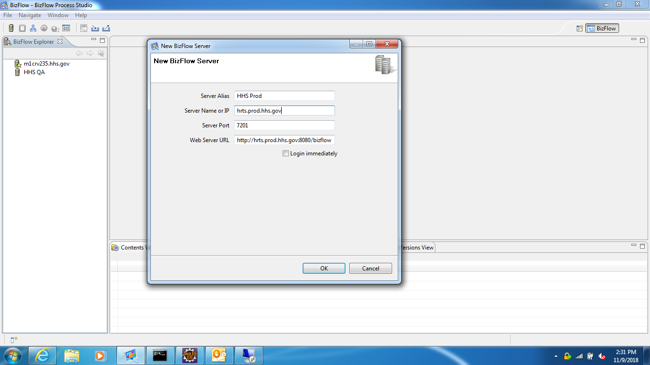

1. Enter “HHS Prod” in “Server Alias”. This will be displayed in left pang.
2. Enter “hrts.prod.hhs.gov” in “Server Name or IP”
3. Enter 7201 in “Server Port”.
4. Web Server URL will be automatically filled in. This URL should be like following.

http://hrts.prod.hhs.gov:8080/bizflow

1. Click “OK”

## Deploy BizFlow BIX file

1. Right Click on “HHS Prod” in left pane from BizFlow Process Studio.
2. Click “Connect” from popup menu.
3. Enter “dev” to “Login ID”
4. Enter password to “Password”.
5. Click “Import” from File menu of BizFlow Process Studio.
6. Click “Browse” button from popup window.
7. Select “CDC_EWITS2_yyyymmdd.bix” from [git]/CDC-BizFlow/process folder.

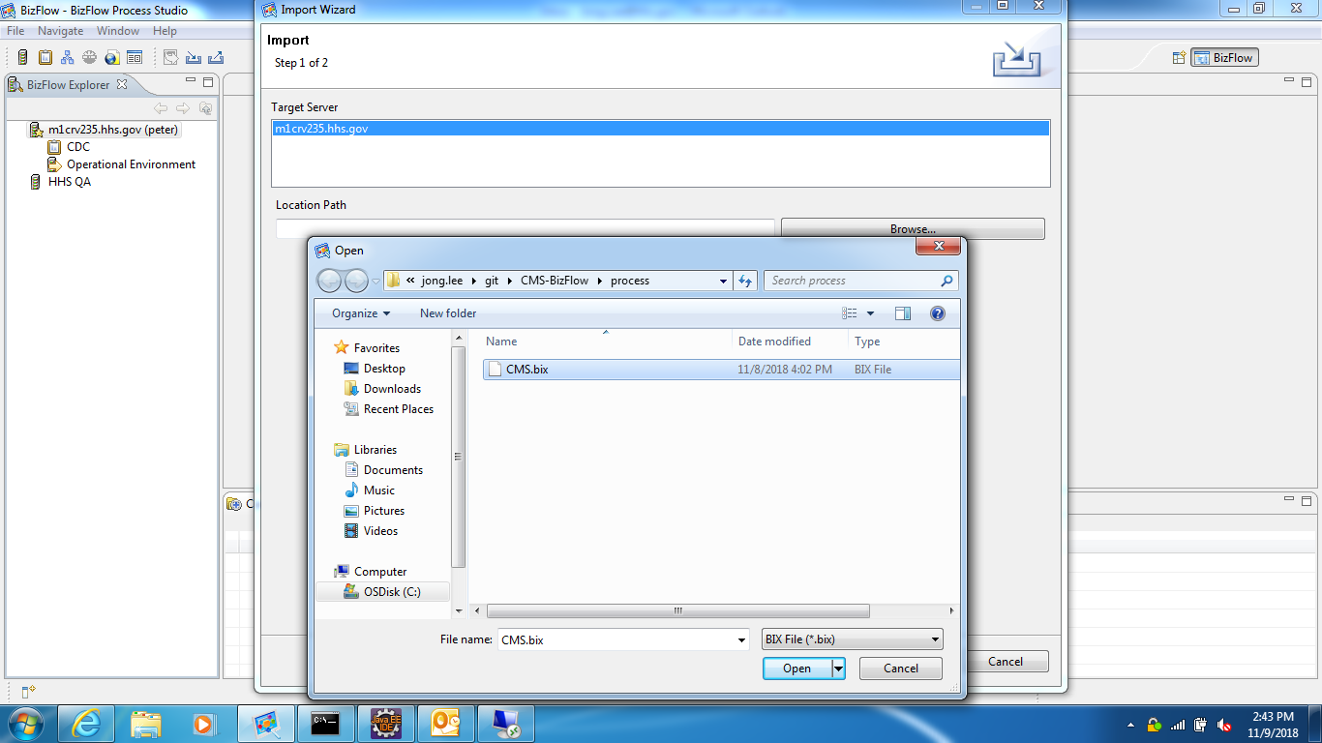

* Select “CDC_EWITS2_yyyymmdd.bix”, not “CDC_EWITS2.bix”.

1. Click “Open” button and then click “Next” button.
2. You will see “Final Step” from Import Wizard. Click all – (minus) icon in left pane so that we can expand all collapsed nodes.

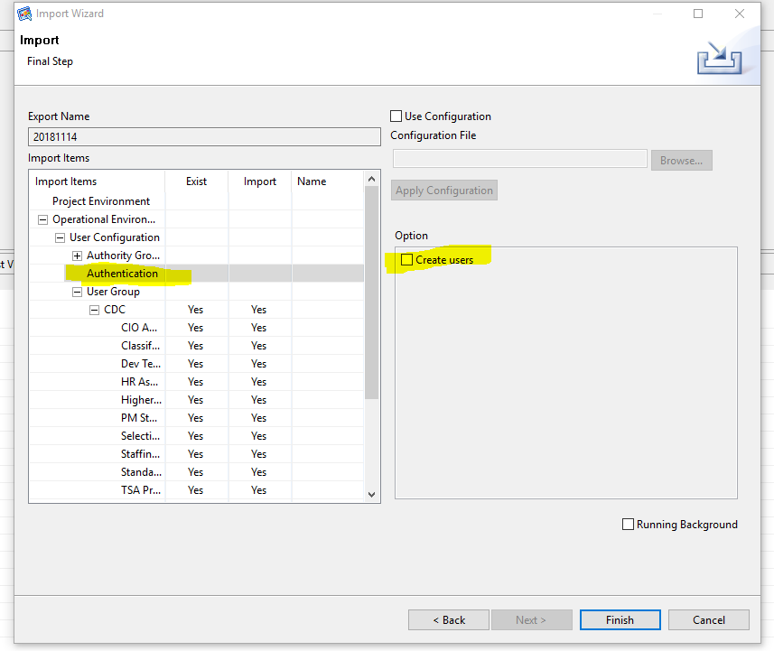

1. The column “Exist” can have “Yes”, “No” or empty. If “Exist” column has other value, then stop import and contact BizFlow.
2. The column “Import” can have “Yes”, “No”. But as default value, it should have “Yes”. If any record has “No”, then change to “Yes”.
3. If there is any “Conflict” in “Import” column, stop import and contact BizFlow.
4. If there is no issues, then click “Finish”.
5. Migration will take about 5 minutes to 10 minutes. Import wizard might not respond due to heavy operation. Do not interrupt the migration.
6. After migration is completed, Notification window will pop up. Click “View log” and check log file.
7. If log file contains any error log, contact BizFlow.

## Deploy BizFlow Report

1. Open command prompet from your HHS Laptop.
2. Go to the folder [BizFlowReporting]/buildomatic/build_conf/default.
3. Open js.jdbc.properteis and enter password to following item. You must set HHS DEV server information since we are exporting reports from DEV server.

metadata.jdbc.password=

1. Go to the folder [BizFlowReporting]/buildomatic
2. Execute following command from command prompt.

|  |
| --- |
| js-export --output-zip ./export/CDCReports.zip --uris /organizations/organization_1/reports/CDC/CDC_Approval_to_Commit,/organizations/organization_1/reports/CDC/CDC_OF8,/organizations/organization_1/reports/CDC/CDC_OF8_All_Grades,/organizations/organization_1/reports/CDC/CDC_Pre_Recruitment_Consultation_report,/organizations/organization_1/reports/CDC/SubReports/Pre_Recruitment_Consultation/Conditions,/organizations/organization_1/reports/CDC/SubReports/Pre_Recruitment_Consultation/Need_and_Funding,/organizations/organization_1/reports/CDC/SubReports/Pre_Recruitment_Consultation/Position,/organizations/organization_1/reports/CDC/SubReports/Pre_Recruitment_Consultation/SME_Data,/organizations/organization_1/Images/CDC/CDC_Logo.jpg,/organizations/organization_1/Images/CDC/Checkbox_No.png,/organizations/organization_1/Images/CDC/Checkbox_Yes.png,/organizations/organization_1/Images/CDC/HHS_Logo.png |

If it fails, contact BizFlow.

1. You will get CDCReports.zip in export folder
2. Copy CDCReports.zip from [git/CDC-BizFlow]/report to [BizFlowReporting]/buildomatic.
3. Execute following command from command prompt.

|  |
| --- |
| js-import --update --skip-user-update --input-zip ./export/CDCReports.zip |

1. If there is any error, stop importing and contact BizFlow.
2. Execute following command from command prompt.

|  |
| --- |
| js-import --update --skip-user-update --input-zip ./export/hhscdcreport_datasource_prod.zip |

1. If there is any error, stop importing and contact BizFlow.

## Deploy BizFlow WebMaker projects

1. Open winscp or ftp client to upload webmaker project file to HHS Production environment.
2. Login with your account from winscp or ftp client.
3. Upload runtime.zip from [git/CDC-BizFlow]/ui to [HHS Production]/hrts/copydir/cdc folder
4. When uploading is completed, from winscp or ftpclient, adjust file permission on runtime.zip to 777.
5. Launch putty and log on into HHS Production with your account.
6. From putty, execute following command

*sudo su sa-bizflow*

1. From putty, execute following command

*cd /hrts/copydir/cdc*

1. From putty, rename runtime.zip to runtime_cdc_yyyymmdd.zip. For example, Today’s date is 11/16/2018, then runtime_cdc_20181116.zip

*mv ./runtime.zip ./runtime_cdc_20181116.zip*

1. From putty, copy runtime_cdc_20181116.zip to /hrts/deploy/baseline/ui

*cp ./runtime_cdc_20181116.zip /hrts/deploy/baseline/ui*

1. From putty, go to /hrts/deploy/baseline/ui folder

*cd /hrts/deploy/baseline/ui*

1. From putty, if there is runtime folder under /hrts/deploy/baseline/ui, remove runtime folder

*rm –Rf ./runtime*

1. From putty, extract runtime_cdc_20181116.zip file.

*unzip runtime_cdc_20181116.zip*

1. From putty, go to /hrts/deploy

*cd /hrts/deploy*

1. From putty, execute following command.

*./deploy_ui.sh prod -nodebug*

1. Above command will import BizFlow webmaker files and shutdown / restart tomcat on HHS Production environment. Normally this will take around 10 minutes.
2. From your HHS Laptop, when you can access following URL, then notify testers to test NEIL on HHS Production environment.

<https://hrts.prod.hhs.gov/bizflow>

About Deloitte

Deloitte provides audit, tax, consulting, and financial advisory services to public and private clients spanning multiple industries. With a globally connected network of member firms in 140 countries, Deloitte brings world-class capabilities and deep local expertise to help clients succeed wherever they operate. Deloitte's 165,000 professionals are committed to becoming the standard of excellence.

Deloitte's professionals are unified by a collaborative culture that fosters integrity, outstanding value to markets and clients, commitment to each other, and strength from cultural diversity. They enjoy an environment of continuous learning, challenging experiences, and enriching career opportunities. Deloitte's professionals are dedicated to strengthening corporate responsibility, building public trust, and making a positive impact in their communities.

Deloitte refers to one or more of Deloitte Touche Tohmatsu, a Swiss Verein, and its network of member firms, each of which is a legally separate and independent entity. Please see www.deloitte.com/about for a detailed description of the legal structure of Deloitte Touche Tohmatsu and its member firms. Please see <http://www.deloitte.com/us/about> for a detailed description of the legal structure of Deloitte LLP and its subsidiaries.

Internal Usage Statement

This publication is for internal distribution and use only among personnel of Deloitte Touche Tohmatsu, its member firms, and its and their affiliates. Deloitte Touche Tohmatsu, its member firms, and its and their affiliates shall not be responsible for any loss whatsoever sustained by any person who relies on this publication.

Copyright © 2012 Deloitte Development LLC. All rights reserved.

Member of Deloitte Touche Tohmatsu